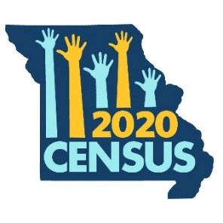
Missouri Counts: 2020 Census Faith Language
Prepared by Missouri Foundation for Health

For Faith Leaders
People in our community trust you. They turn to you for spiritual guidance, when dealing with personal hardship, and they look to you for ways to give back to the community. As we approach the 2020 Census, your voice and willingness to spread educational messages about the 2020 Census can play a powerful role in making sure our communities are counted. Consider using the language below in an upcoming church bulletin, or use these messages as talking points during announcements at your places of worship.

Language for Faith Bulletin
We all have an opportunity to help [community name] grow and thrive. One of the most important things we can do to help our neighbors in-need is respond to the 2020 Census, because it determines the federal funding our community will receive. The Census happens every 10 years.

When every adult and every child in our community is counted, we get more money to fix our roads, support for our health care centers to provide for our neighbors, and funding for our schools to take care of our kids. We get the support we need for important programs that help our neighbors when they fall on tough times, like SNAP (food stamps) and Medicaid. This means more children and families can get the food and care they need to be healthy.

For every adult and every child that is not counted, our state will lose $1,300 in federal dollars every year. That adds up to $13,000 per person over the next 10 years. Those are funds that we won’t get for our roads and bridges, hospitals, and schools.

Talk to your loved ones today about the importance of responding to the 2020 Census. Starting March 12, you’ll be able to respond at my2020census.gov, toll-free at 844-330-2020, or by mail.

Optional
The U.S. Census Bureau will keep your information private. The census will not ask if you are a citizen.

