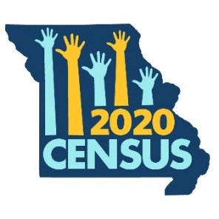
Missouri Counts: 2020 Census Newsletter Language
Prepared by Missouri Foundation for Health

For use until March 12, 2020
2020 Census: Help Missouri Get Its Fair Share

The 2020 Census is our chance to make sure the hard-earned tax dollars we send to Washington, D.C. make their way back to Missouri. For every adult and every child that is not counted in the Census, our state will lose $1,300 in federal dollars every year. That adds up to $13,000 per person over the next 10 years.

When every Missourian is counted, we get our fair share of funding to pave our roads and rebuild bridges. Our health care programs and community health centers get more funding to take care of our family, friends, and neighbors. And our schools get important funding to take care of our kids.

Let’s tell our neighbors about the importance of the 2020 Census. Because Missouri Counts!

For use beginning March 12, 2020
Respond to the 2020 Census TODAY!

You can now respond to the 2020 Census at my2020census.gov! This is our chance to make sure the hard-earned tax dollars we send to Washington, D.C. make their way back to Missouri. For every adult and every child that is not counted in the Census, our state will lose $1,300 in federal dollars every year.

When every Missourian is counted, we get our fair share of funding to pave our roads and rebuild bridges. Our health care programs and community health centers get more funding to take care of our family, friends, and neighbors. And our schools get important funding to take care of our kids.

Respond to the 2020 Census at my2020census.gov, toll-free number at 844-330-2020, or by mail. Because Missouri Counts!

